Step 0 Source: Intake Result: Filing Status, Dependency
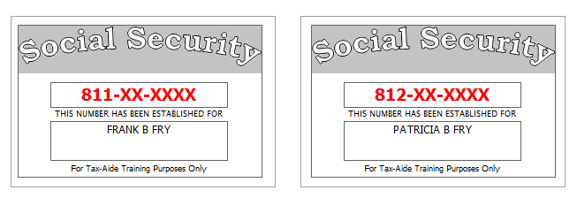
Frank’s granddaughter, Mary Fry, moved in with them in April of the tax year. He provides all her support. She was born in France where her parents were stationed.
Reference: 4012 Tab A, B, C
Tool: IRS Interactive Tax Assistant (link on Preparer page)
Tool: AARP Resource Tool for Counselors (Laminated Flow Chart)
Tool: TP4F Qualifying Child/Qualifying Relative Flowchart Tool (link on Preparer page)
Tool: Dependent Calculator (link on Preparer page)

Step 1a Source: Intake Part I, II, VII TWO Screen: Main Info
Reference: 4012 K-6, K-7, K-22
Use the Filing Status and Dependency Status from Step 0
Refund Monitor
AGI | Refund | NJ 39 | NJ 56/66 | Notes
Hint: Look at References for special instructions for deceased spouse
Hint: Don’t worry about RTN / DAN for direct deposit at this point.
Q: Did you put anything on % address line?
Step 1b Source: Intake Part I TWO Screen: NJ 1040 Pg1
Reference: NJ Special Handling p5
Tool: NJ Municipality Code Lookup Tool (link on Preparer page)
Tool: NJ 1040 Instructions – Municipality Code Table
Tool: TWO State Help
Refund Monitor
AGI | Refund | NJ 39 | NJ 56/66 | Notes
 |  |  |  | Hint: Use NJ Municipality Code Lookup Tool
Step 1c Source: Intake Part I, II TWO Screen: NJ 1040 Pg 2
Frank wants to handle the Gubernatorial Election Campaign Fund the same way as the Presidential Election Campaign Fund.
Everyone in the tax family had MEC for the entire year.
Reference: NJ Special Handling p5
Refund Monitor
AGI | Refund | NJ 39 | NJ 56/66 | Notes
 |  |  |  | Hint: Gubernatorial Elections Fund – see Notes
Step 1d Source: Intake Part VII TWO Screen: Prep Use
If asked, Frank is a Veteran from the US Armed Forces.
Refund Monitor
AGI | Refund | NJ 39 | NJ 56/66 | Notes
 |  |  |  | BP: Do not fill in line 14 until after QR

Step 2a Source: 1099-DIV TWO Screen: Dividend Stmt
Acme Financial | End of Year Tax Information Statement  Account 203040506 | Statement Date: 01-30-2015  Page 1 of 1 | 2014
123 Main  P.O. Box 07978-123  Pluckemin, NJ 07978  PAYER’S Federal ID No: 71-9XXXXXX | Frank B. Fry  123 Elm  Pluckemin, NJ 007978  RECIPIENT’S ID No: 811-XX-XXXX | Your Broker:  SERGE BRONSKI  888-555-5555  sbronski@acme.com

Dividends and Distributions – 1099-DIV – Reported to IRS
1a | Total ordinary dividends (includes line 1b) | 1,565.00
1b | Qualified dividends | 875.00
2a | Total capital gain distributions (includes lines 2b, 2c, 2d) | 737.00
2b | Unrecaptured Section 1250 gain | 0.00
2c | Section 1202 gain | 0.00
2d | Collectibles (28%) gain | 0.00
3 | Nondividend distributions | 0.00
4 | Federal Income tax withheld | 0.00
5 | Investment expenses | 0.00
6 | Foreign tax paid | 0.00
7 | Foreign country or US passion
8 | Cash liquidation distributions | 0.00
9 | Noncash liquidation distributions | 0.00
10 | Exempt-interest dividends (includes line 11) | 0.00
11 | Specified private activity bond interest dividends (AMT) | 0.00
12 | State
13 | State ID number
14 | State tax withheld | 0.00
 | FATCA filing requirement | NO

Reference: 4012 D-11
Refund Monitor
AGI | Refund | NJ 39 | NJ 56/66 | Notes
2,302 | 0 | 0 | 0 | Hint: Dividend Stmt worksheet is under Sch B in the tree
Step 2b Source: Notes TWO Screen: Sch B
The Frys had no financial involvement of any kind in any foreign country.
Refund Monitor
AGI | Refund | NJ 39 | NJ 56/66 | Notes
2,302 | 0 | 0 | 0 | Hint: Answer any Part III questions that are red
Step 3 Source: 1099-R TWO Screen: 1099R
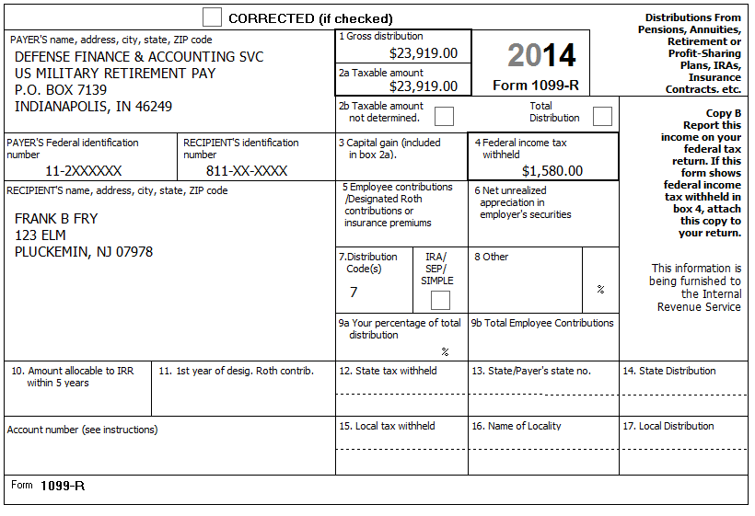
Reference: 4012 D-20, D-21, D-27 A. Example 1
Reference: NJ Special Handling p2
Refund Monitor
AGI | Refund | NJ 39 | NJ 56/66 | Notes
26,221 | 1,580 | 0 | 0 | Hint: See NJ Special Handling for Military Pensions  Check: NJ 1040, line 19a = 0
Step 4a Source: 1099-R TWO Screen: 1099R
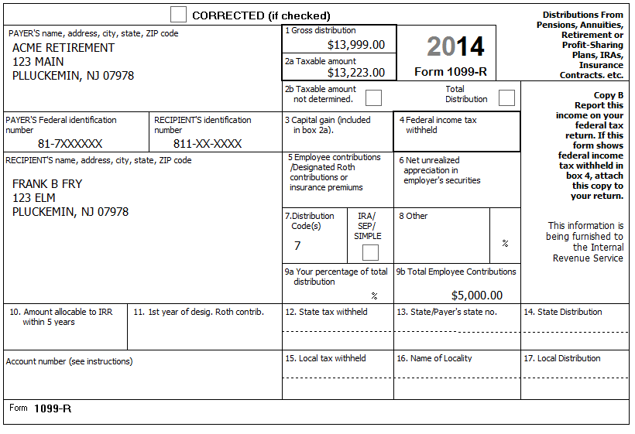
Reference: 4012 D-20, D-21, D-27 C. Example 3
Reference: NJ Special Handling p3
Refund Monitor
AGI | Refund | NJ 39 | NJ 56/66 | Notes
39,444 | 462 | 0 | 0 | Check: NJ 1040, line 19a = 13,223
Step 4b Source: 1099R TWO Screen: NJ 1040 Pg 2, Line 19b
Reference: NJ Special Handling p5
Refund Monitor
AGI | Refund | NJ 39 | NJ 56/66 | Notes
39,444 | 462 | 0 | 0 | Hint: Follow procedure in NJ Special Handling, p5 for NJ 1040 Pg 2, Line 19b (Excludable pensions)  Check: NJ 1040, line 19b = 776  Check: NJ 1040, line 19a (13,223) + line 19b (776) = 13,999 (Box 1)
Step 5 Source: SSA-1099 TWO Screen: 1040 Wkt1
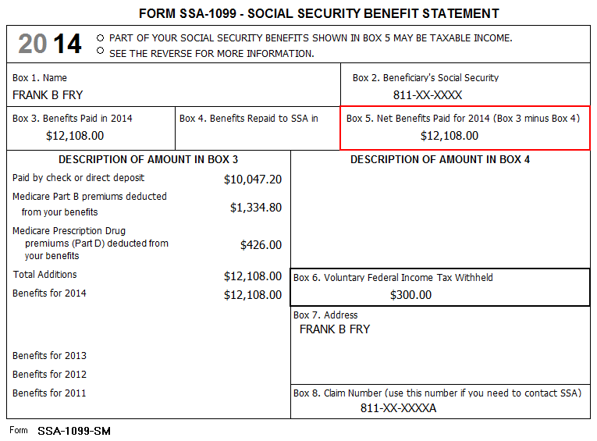
[no notes]
Reference: 4012 D-26
Refund Monitor
AGI | Refund | NJ 39 | NJ 56/66 | Notes
46,717 | 16 | 0 | 0 | BP: Use Scratch Pad linked to “Medicare Parts B, C, and D to Schedule A” row, Taxpayer column to document breakdown of Medicare premiums if more than one of Part B, C, D  Check: A Detail, Medicare from 1040 worksheet box = 1,761
Step 6 Source: SSA-1099 TWO Screen: 1040 Wkt1
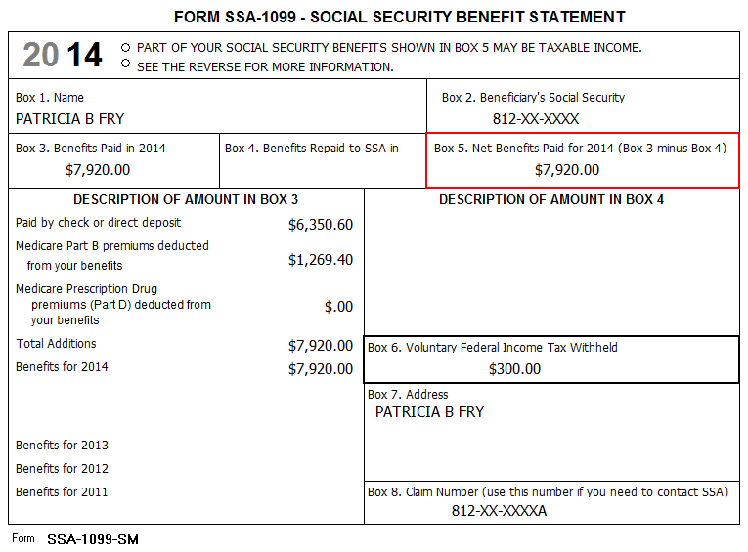
[no notes]
Reference: 4012 D-26
Refund Monitor
AGI | Refund | NJ 39 | NJ 56/66 | Notes
50,083 | (186) | 0 | 0 | Check: A Detail, Medicare from 1040 worksheet box = 3,030
Step 7 Source: W2-G TWO Screen: W2G
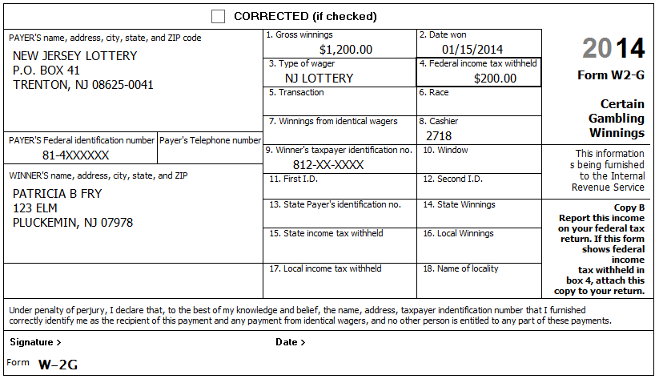
Frank has a breakdown of their gambling losses:
 | Lottery | Slots | Poker | Total
Frank | 600 | 300 | 200 | 1,100
Pat | 500 | 950 |  | 1,450
Total | 1,100 | 1,250 | 200 | 2,550
Reference: NJ Special Handling p3
Refund Monitor
AGI | Refund | NJ 39 | NJ 56/66 | Notes
52,303 | (316) | 0 | 0 | Hint: Need to add new W2G (if blank W2G not already in tree)  BP: Include appropriate losses directly on W2G (bottom right)  Check: Sch A, line 28 = 1,200
Step 8 Source: Notes TWO Screen: 1040 Pg 1
Frank and Pat received a NJ Income Tax refund of $103 in 2014 (for their NJ 2013 return).
They itemized last year and their Sch A shows line 5b checked (indicating their state sales tax amount was larger than their state income tax amount). Their itemized deduction amount was several thousand dollars more than their standard deduction. Their taxable income was greater than zero.
Refund Monitor
AGI | Refund | NJ 39 | NJ 56/66 | Notes
52,303 | (316) | 0 | 0 | Hint: Answer question above Line 10
Step 9a Source: Notes TWO Screen: Sch A
The Frys paid $7,498 in property tax on their main home (based on tax statement).
They also paid $3,623 in property tax for the empty lot they own next door.
Their mortgage interest was $2,164 (from a Form 1098).
Frank had $6,875 in funeral expenses after Pat passed away.
They paid $60 for safe deposit box for their financial papers.
Frank paid $1,052 in fees for investment expenses.
They had $2,550 in gambling losses.
Reference: 4012 F3 thru F-6
Refund Monitor
AGI | Refund | NJ 39 | NJ 56/66 | Notes
52,303 | (234) | 0 | 0 | Hint: Some items in list may not be deductible or may have already been entered  BP: Use Scratch Pad linked from Line 6, 4th box to document source of non-principal residence real estate tax amount  BP: Defer handling PTR & Homestead Benefit until Sch A is complete.  Check: Sch A, Line 4=0; Line 9=11,943; Line 15=2,164; Line 19=0; Line 27=66; Line 28=1,200
Step 9b Source: Notes TWO Screen: NJ 1040 Pg 3, Worksheet F
The Frys qualified for the NJ PTR program last year. Their base year tax amount is $7,303.
Reference: NJ Special Handling p12
Refund Monitor
AGI | Refund | NJ 39 | NJ 56/66 | Notes
52,303 | (234) | 0 | 50 | Hint: What is correct number to use if TP is in the NJ PTR program?
Step 9c Source: Notes TWO Screen: NJ 1040 Pg 3, Line 37
According to the postcard from the tax office: – Block=50001, Lot-00002, Qualifier is blank.
Reference: NJ Special Handling p6
Refund Monitor
AGI | Refund | NJ 39 | NJ 56/66 | Notes
52,303 | (234) | 0 | 50 | BP: Fix amount on line 37a via a Scratch Pad attached to line 37a  Hint: In this case, County / municipality code same as on NJ 1040 Pg1  Hint: Read NJ Special Handling for how to handle 37c checkbox

Step 10 Source: Notes TWO Screen: A Detail
Medical Expenses (Unreimbursed):
- Doctor bills: $1,923
- Hospital bills: $1,168
- Medical mileage: 93 miles per month (1,116 total miles)
- Prescription drugs: $1,756
- Vitamins & Herbal Remedies: $522
- Weight loss program (not prescribed): $300
- Prescription eyeglasses: $210
- Non-Prescription high-reflective polarized sunglasses: $89
Charitable:
- Church donations (statement from church): $850
- Church raffle ticket (didn’t win): $25
- Public Broadcasting System (receipt from PBS): $201
- Candidate for local town council: $50
- Salvation Army (Receipt for FMV for used clothes in good condition): $350
Reference: 4012 F-7, F-8
Refund Monitor
AGI | Refund | NJ 39 | NJ 56/66 | Notes
52,303 | 617 | 0 | 50 | Hint: Some items in list may not be deductible or may have already been entered  Check: Sch A, Line 1 = 8,349; Line 19 = 1,401
Step 11 Source: Notes TWO Screen: Sales Tax
Frank paid $1,400 in sales tax on the purchase of a brand new red convertible sports car in July, 2014.
Reference: 4012 EXT-3
Refund Monitor
AGI | Refund | NJ 39 | NJ 56/66 | Notes
52,303 | 757 | 0 | 50 | BP: Use Scratch Pad linked to line 8 to document source of amount  Check: Sch A, line 5b = 2,222

Step 12 Source: Notes TWO Screen: Sch A
The Frys are in the NJ PTR program. Their base amount is $7,303. Last year’s PTR rebate was $172.
They itemized last year and their Sch A shows line 5b checked (indicating their state sales tax amount was larger than their state income tax amount). Their itemized deduction amount was several thousand dollars more than their standard deduction. Their taxable income was greater than zero.
The Frys received a $634 Homestead Benefit (HB) payment in 2014 (for property taxes paid three years ago). They did not bring their three years ago return, but are pretty sure they itemized that year. [Note: We know there were no actual HB payments in 2014 – it is included here as practice for 2015.]
Reference: NJ Special Handling p4, p9
Refund Monitor
AGI | Refund | NJ 39 | NJ 56/66 | Notes
52,303 | 677 | 0 | 50 | BP: Use Scratch Pad to document PTR and HB adjustments  Hint: There is already a Scratch Pad on the 4th box (from real estate tax on empty lot), so just add PTR and HB amounts to it
Step 13 Source: Notes TWO Screen: 1040 ACA Wkt
Everyone in the tax family had MEC (not from Marketplace) for the entire year.
Reference: 4012 ACA Tab
Reference: ACA TaxWise Procedures (TY2014 version)
Refund Monitor
AGI | Refund | NJ 39 | NJ 56/66 | Notes
52,303 | 677 | 0 | 50 | Hint: Everyone marked as Full
Step 14 Source: Notes TWO Screen: Diagnostics
Should be done with Federal return – Run Diagnostics – Resolve any issues.
Step 15 Source: Notes TWO Screen: NJ 1040 Pg 3, Line 45
Frank did not make any out of state purchases.
Refund Monitor
AGI | Refund | NJ 39 | NJ 56/66 | Notes
52,303 | 677 | 0 | 50
Step 16 Source: Notes TWO Screen: NJ Ret Wkt
Refund Monitor
AGI | Refund | NJ 39 | NJ 56/66 | Notes
52,303 | 677 | 0 | 50 | Hint: Line 10a
Step 17 Source: Notes TWO Screen: Diagnostics
Should be done with NJ return – Run Diagnostics – Resolve any issues.
Step 18 Source: Intake TWO Screen: 1040 Pg 2
Refund via check for federal refund – nothing to do.
Step 19 Source: Notes TWO Screen: NJ DD Wkt
Frank would like any NJ refund or amount due handled the same way as on his federal return.
Refund Monitor
AGI | Refund | NJ 39 | NJ 56/66 | Notes
52,303 | 677 | 0 | 50 | Hint: Select appropriate option
Step 20 Source: Notes TWO Screen: Diagnostics
Run Diagnostics (and Create e-File) – Resolve any issues
For a client return, the next step would be Quality Review…

